**Working ManifoldCF settings to crawl filesystem directory**(Manifold v1.9 with Solr v4.5.1)

**My Repository connection (filesystem)**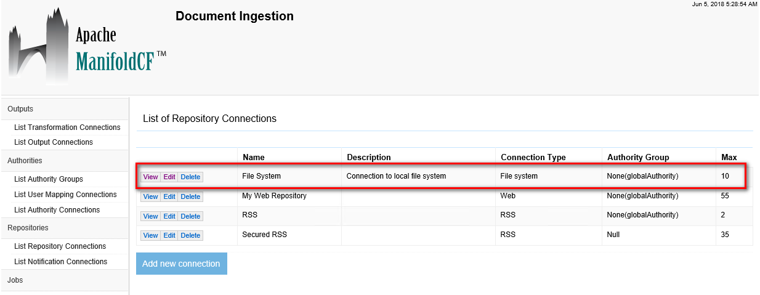  
  
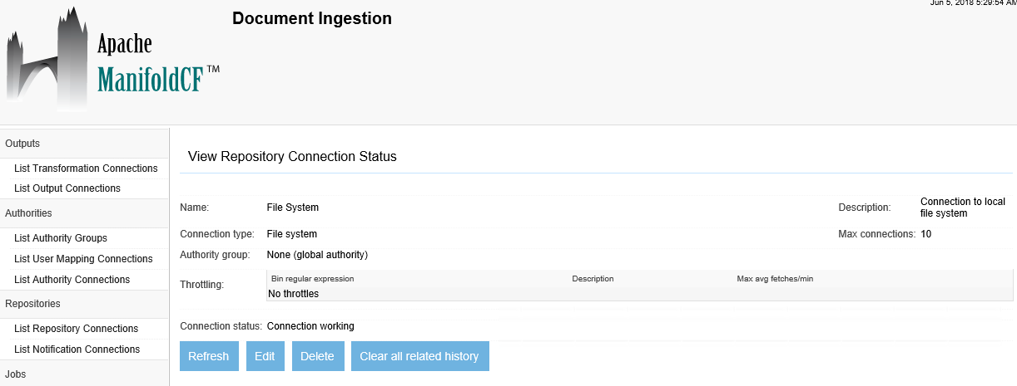  
**Note**: No authority group required.  
  
  
  
**MY Output connection (Solr)**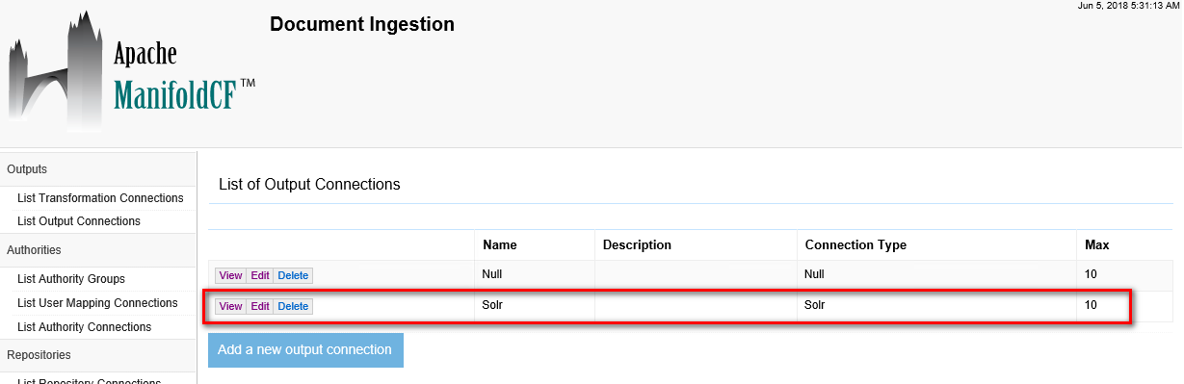Name:  
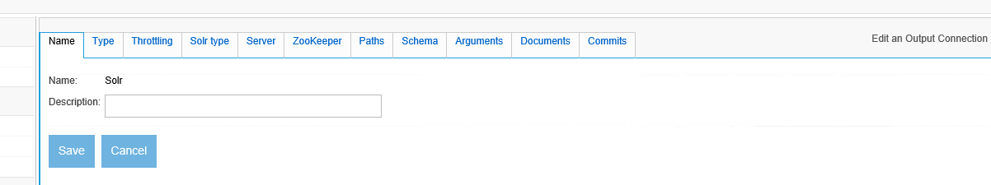

Type:  
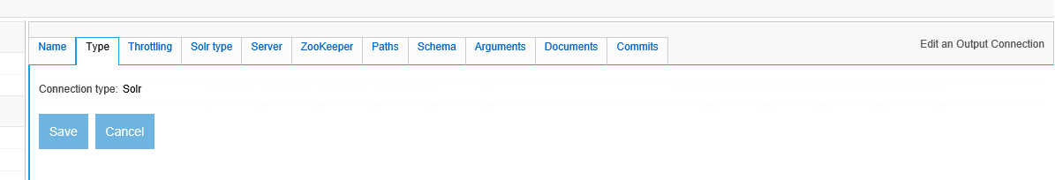Throttling:  
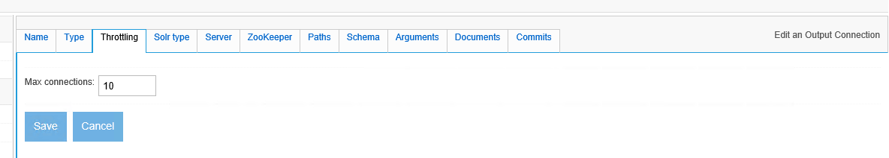Solr type:  
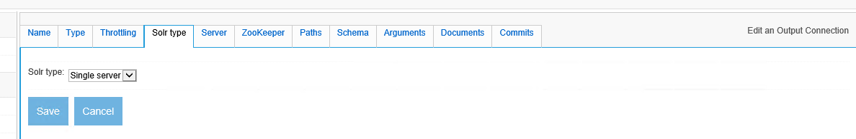

Server:  
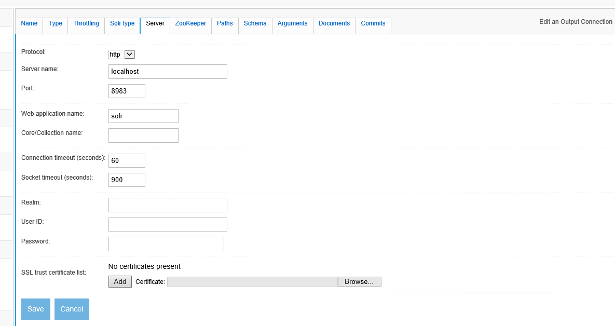 **Note**: We can specify the Solr Core here, should we want to have multiple Cores in the same Solr “engine”.

ZooKeeper:  
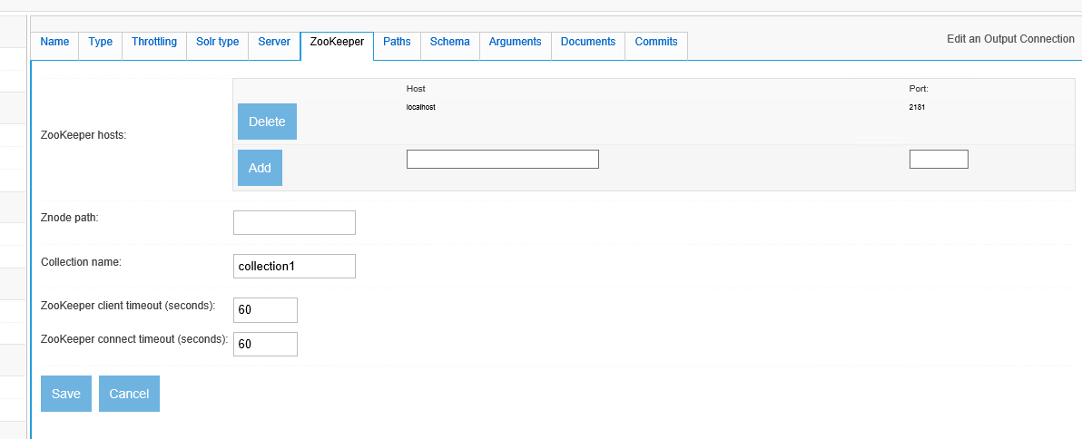  
  
  
Paths:  
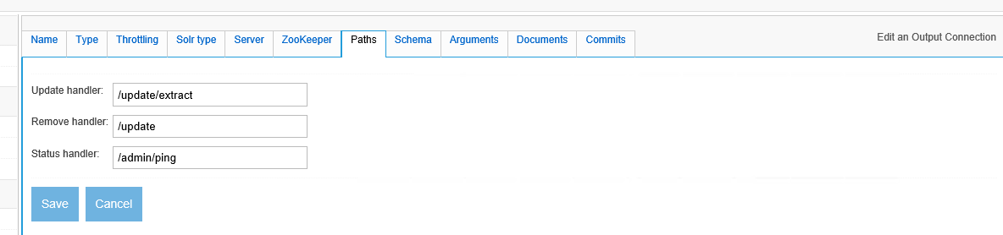  
  
  
Schema:  
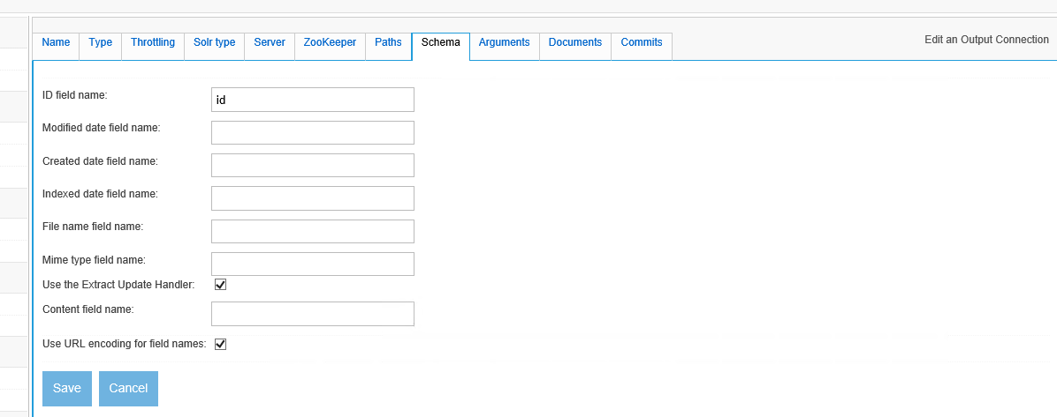

Arguments:  
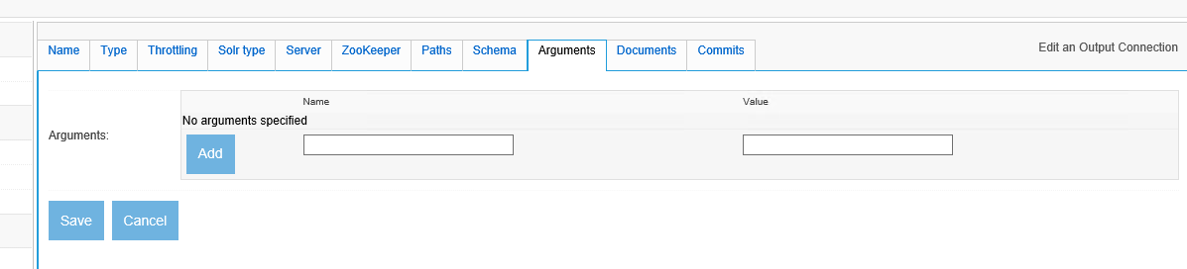

Documents:  
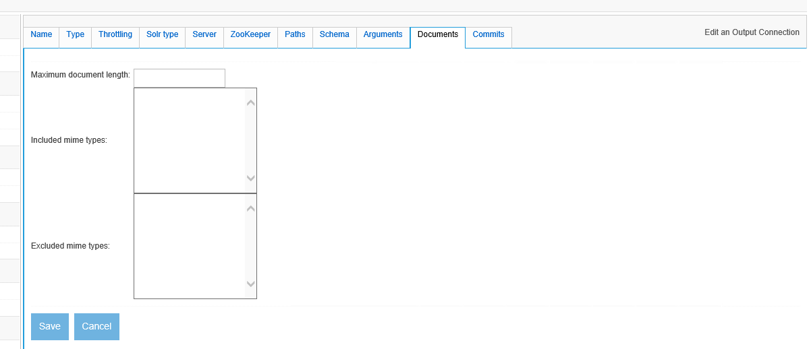

Commits:  
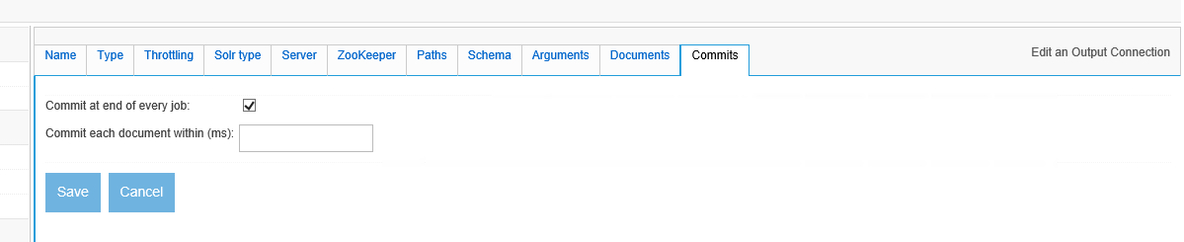

**My Job (this links the repository connection and output connection)**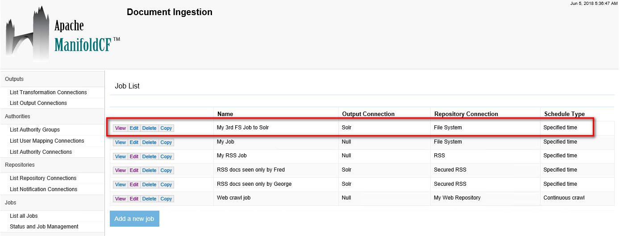Name:  
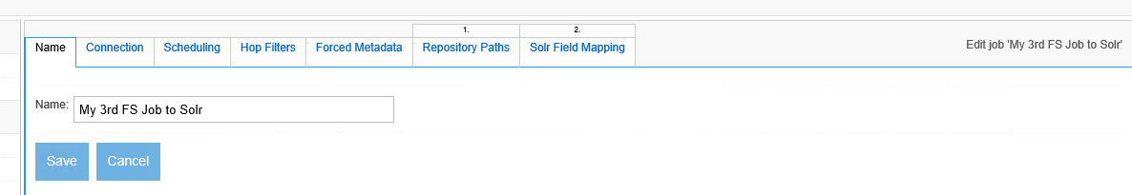  
  
  
Connection:  
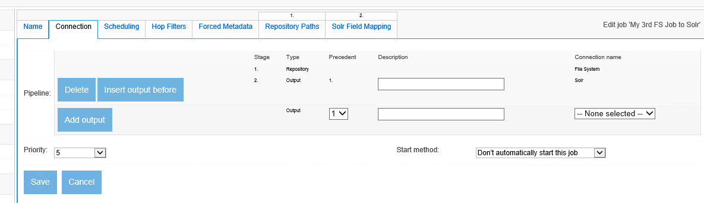  
**Note:** It’s very small, but this shows the repository connection (filesystem) and the output connector (Solr):  
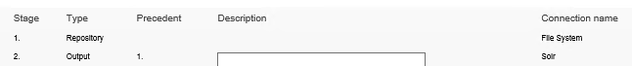

Scheduling:  
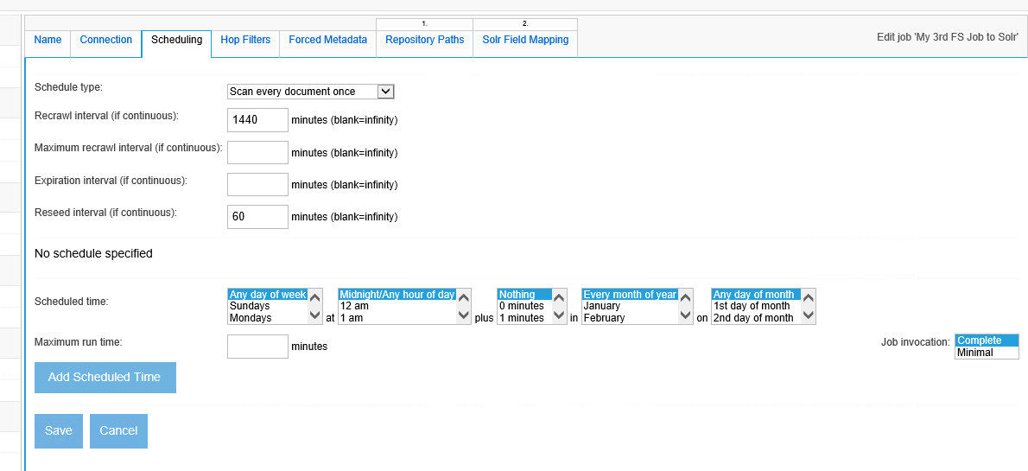  
  
  
Hop Filters:  
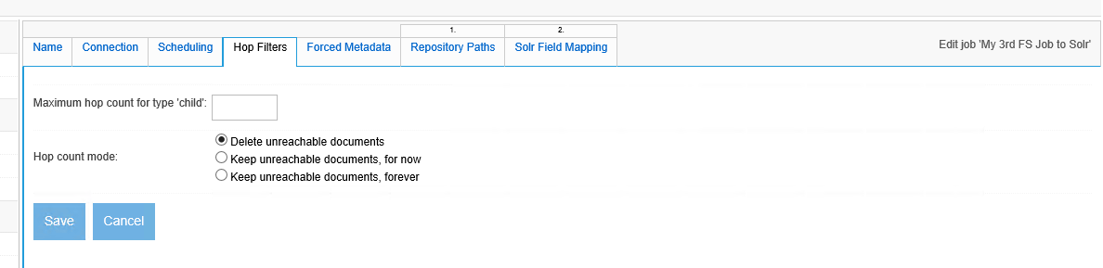

Forced Metadata:  
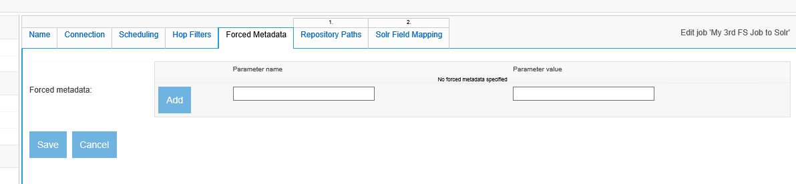  
**Note:** This is probably how we could implement a Solr “facet” for different ManifoldCF Jobs that send documents to the same Solr core/index.

Repository Paths:  
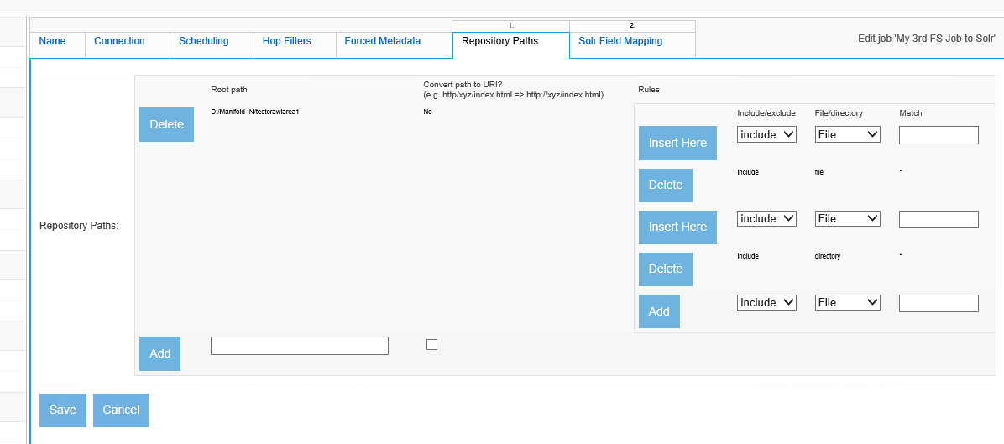  
**Note:** It’s very small, but here we have the input filesystem directory to crawl:  
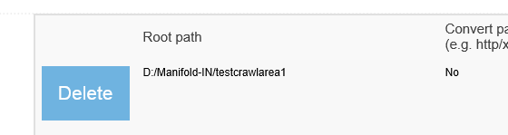  
  
  
Solr Field Mapping:  
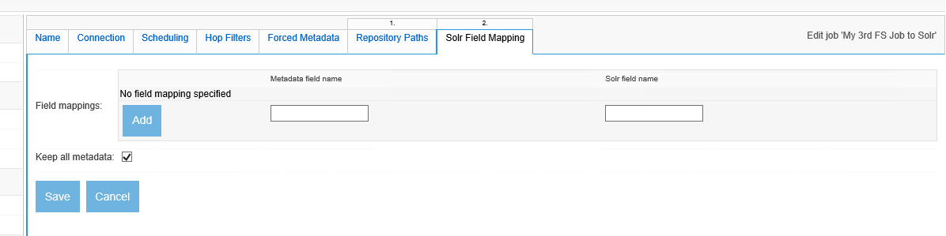

*JeremyC 5-6-2018***END**